

Practices for Secure Software Report

Table of Contents
Document Revision History 3
Client 3
Instructions 3
Developer 4
1. Algorithm Cipher 4
2. Certificate Generation 4
3. Deploy Cipher 4
4. Secure Communications 5
5. Secondary Testing 5
6. Functional Testing 6
7. Summary 6
8. Industry Standard Best Practices 7

Document Revision History

Version | Date | Author | Comments
1.0 | 10/18/2026 | Kilanda Eferobor

Client



Instructions

Submit this completed practices for secure software report. Replace the bracketed text with the relevant information. You must document your process for writing secure communications and refactoring code that complies with software security testing protocols.

- Respond to the steps outlined below and include your findings.
- Respond using your own words. You may also choose to include images or supporting materials. If you include them, make certain to insert them in all the relevant locations in the document.
- Refer to the Project Two Guidelines and Rubric for more detailed instructions about each section of the template.

Developer
Kilanda Eferobor

Algorithm Cipher

The encryption algorithm I would recommend for Artemis Financial is AES-256. This is a symmetric encryption algorithm, which means that the same secret key is used to encrypt and decrypt the data. AES can use 128-, 192-, or 256-bit keys. However, I would recommend the 256-bit option because Artemis Financial will be protecting sensitive financial information.
Hash functions work differently from encryption because they create a message digest that can be used to verify whether data has been changed. For example, SHA-256 creates a 256-bit hash value. Random numbers are also important in cryptography because they can be used when creating secure keys and other values needed during encryption.
When it comes to symmetric encryption, it uses one secret key for both encryption and decryption, while asymmetric encryption uses a public key and a private key. For stored financial data, AES-256 is a good choice because the information can be encrypted and later decrypted by an authorized user with the correct key.
Encryption methods have changed over time as older algorithms have become weaker or outdated. AES is a current encryption standard and is specified by NIST in FIPS 197. Because security threats continue to change, Artemis Financial should continue reviewing its encryption methods and update them when stronger standards or security needs require it.

Certificate Generation
Insert a screenshot below of the CER file.

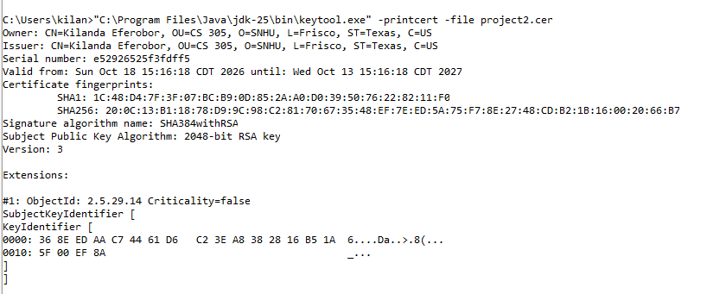
I generated a self-signed certificate using the Java Keytool and exported it as a CER file. The certificate uses a 2048-bit RSA public key and the SHA384withRSA signature algorithm. The screenshot above shows the certificate owner, issuer, validity dates, fingerprints, and public key information.

Deploy Cipher
I implemented SHA-256 in the application to create a checksum for the data being transmitted. The screenshot below shows the unique data string containing my name, the SHA-256 algorithm, and the checksum value that was generated. This checksum can be used to verify whether the data has been changed.

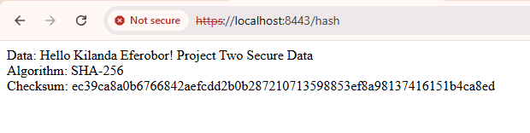

Secure Communications
Insert a screenshot below of the web browser that shows a secure webpage.

I updated the application properties so the web application uses HTTPS on port 8443 instead of an unsecured HTTP connection. The application uses the self-signed certificate that was created earlier in the project. The screenshot below shows the application running successfully at https://localhost:8443/hash.

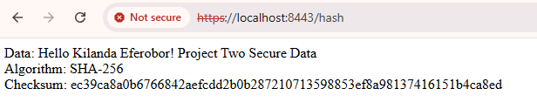

Secondary Testing
Insert screenshots below of the refactored code executed without errors and the dependency-check report.

I ran the OWASP Dependency-Check tool on the refactored application to test for known vulnerabilities. The application compiled and executed successfully, and the dependency-check report was generated for review. The screenshots below show the application running without errors and the results of the dependency-check scan.

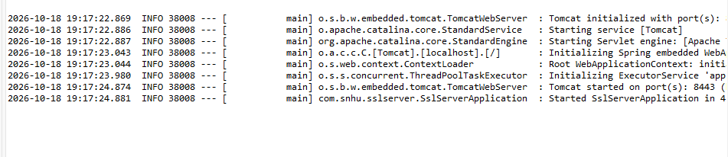

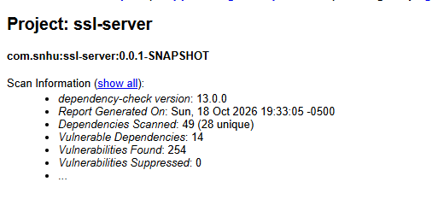

Functional Testing
Insert a screenshot below of the refactored code executed without errors.

I manually reviewed the refactored code for syntactical, logical, and security issues. I verified that the SHA-256 checksum was created correctly, the `/hash` endpoint returned the expected data, and the application ran successfully over HTTPS. I did not find any syntax or logic errors in the code that I added. The screenshot below shows the application executing successfully without errors.

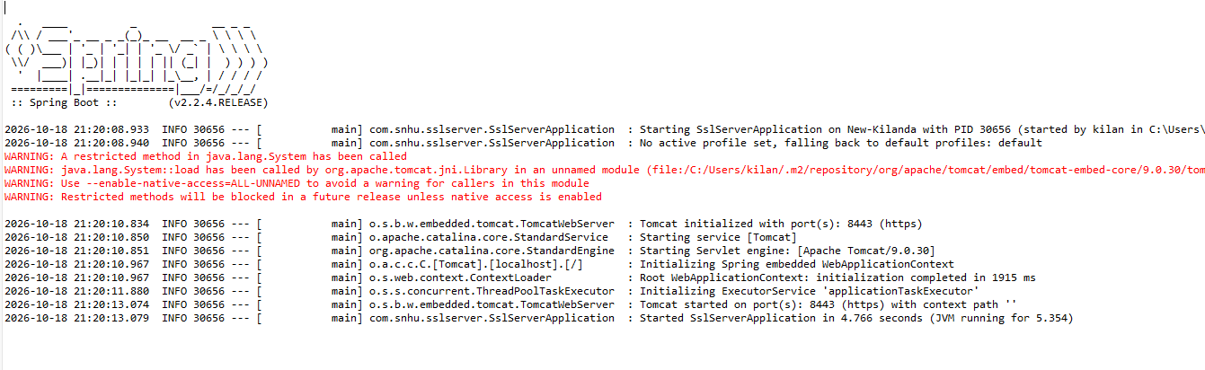

Summary

The code for Artemis Financial was refactored by adding several layers of security to the application. I added a SHA-256 checksum to verify that data had not been changed, created a self-signed certificate, and configured the application to use HTTPS on port 8443. I also used the OWASP Dependency-Check tool to test the project for known vulnerabilities and manually reviewed the code for syntax, logic, and security issues.
Using the Vulnerability Assessment Process Flow Diagram, the main areas I addressed were cryptography, client/server security, code error, code quality, and plug-ins. Cryptography was addressed by using SHA-256 and by creating a certificate for secure communication. Client/server security was improved by changing the application from HTTP to HTTPS. Code error and code quality were addressed by reviewing the code and making sure the application ran successfully without errors. Plug-in security was addressed by using OWASP Dependency-Check to scan the application for known vulnerabilities.
These changes added multiple layers of security instead of relying on only one method. The checksum helps verify data integrity, HTTPS helps protect data while it is being transmitted, the certificate helps support secure communication, and dependency testing helps identify known vulnerabilities in the software components. Together, these changes help make the application more secure and better support Artemis Financial's need to protect financial and customer information.

Industry Standard Best Practices

I applied industry standard best practices by using secure coding methods throughout the application. I used SHA-256 to create a checksum for data verification, configured the application to use HTTPS, created a self-signed certificate for secure communication, and used the OWASP Dependency-Check tool to scan the project for known vulnerabilities. I also manually reviewed the code to make sure the application ran correctly and that the changes I made did not introduce new syntax, logic, or security problems.
Using secure coding best practices helps maintain the security that already exists in the application while also adding new protections. These practices are important to Artemis Financial because the company handles sensitive customer and financial information. Following security standards can help reduce the risk of data being changed, exposed, or accessed by unauthorized users. It can also help protect the company’s reputation, maintain customer trust, and reduce the risk of security problems that could affect the business.

